Let's implement social login in the React frontend. I will show you how to Login with Google. If you want to also implement Login with Facebook or Twitter. The process will be same.

First let's install a package that will easily allows us to implement Login with Google.

npm i react-google-login

Feel free to read more about this package in <https://www.npmjs.com/package/react-google-login>

If you want to implement login with facebook or twitter. There are package available. Once you complete Login with Google, you will be confident enough to implement Facebook and Twitter login on your own. It will be similar.

[Login with Facebook](https://www.npmjs.com/package/react-facebook-login)

[Login with Twitter](https://www.npmjs.com/package/login-with-twitter)

**To get google clientId, you need to create new Google OAuth Client. Here are the setps:**

* Go to <https://console.cloud.google.com/apis/credentials/oauthclient>
* If you are not logged in to gmail, you will be asked to login first.
* Pick Application Type - Web Application, Give it a name and hit create (see screenshot below)

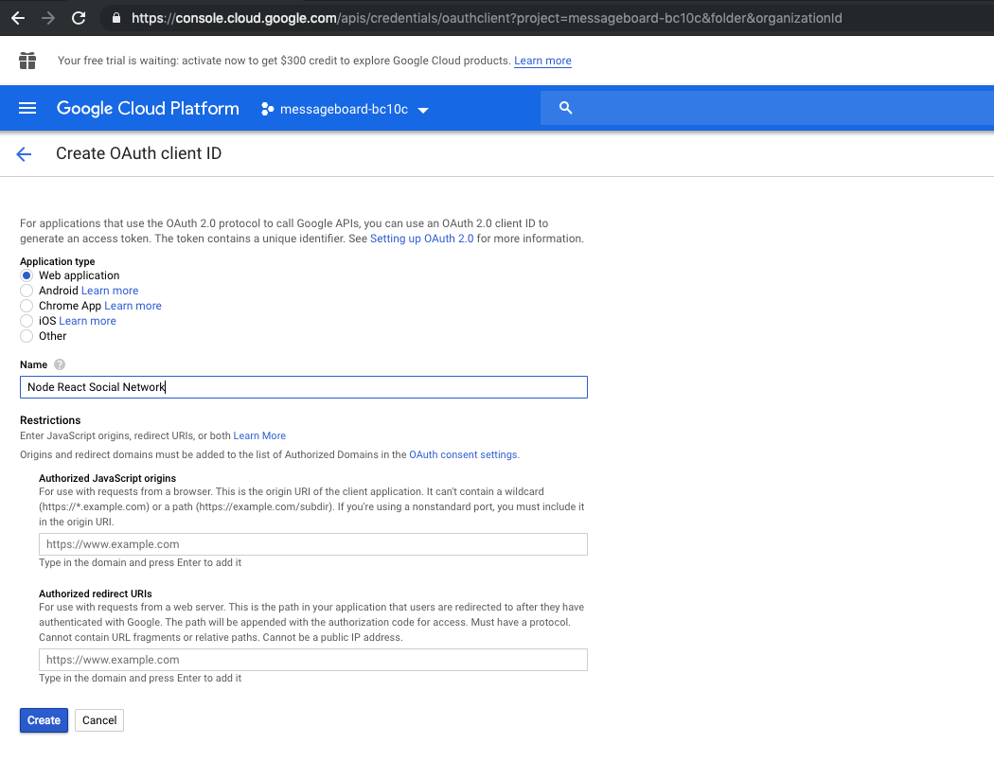

Then you will be automatically redirected to this page (see screenshot)

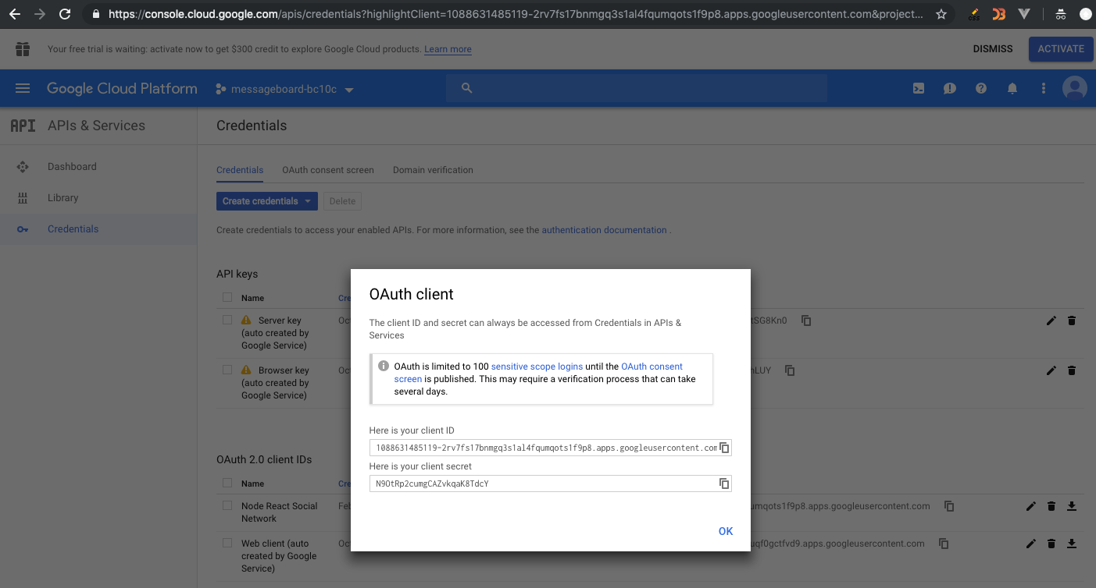

**That's your clientId and client secret there. Copy that clientId to use.**

For some reason, if you don't get redirected to this page, you can always go here:

<https://console.cloud.google.com/apis/credentials/oauthclient>

Then click on the top left icon (hamburger menu - three white lines)

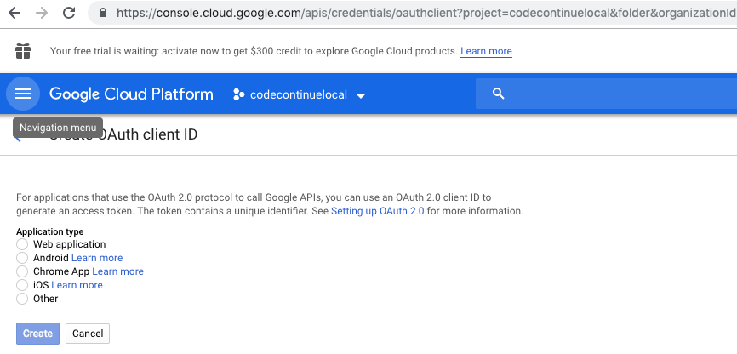

Once you click on that icon, the left sidebar will be visible like so:

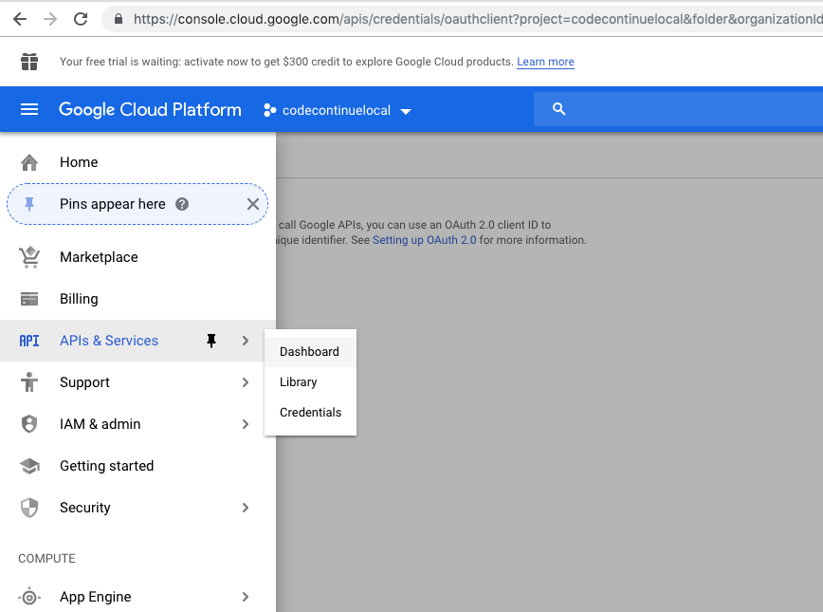

Click on the API's & Services > Credentials. There will be all your app credentials etc (see screenshot)

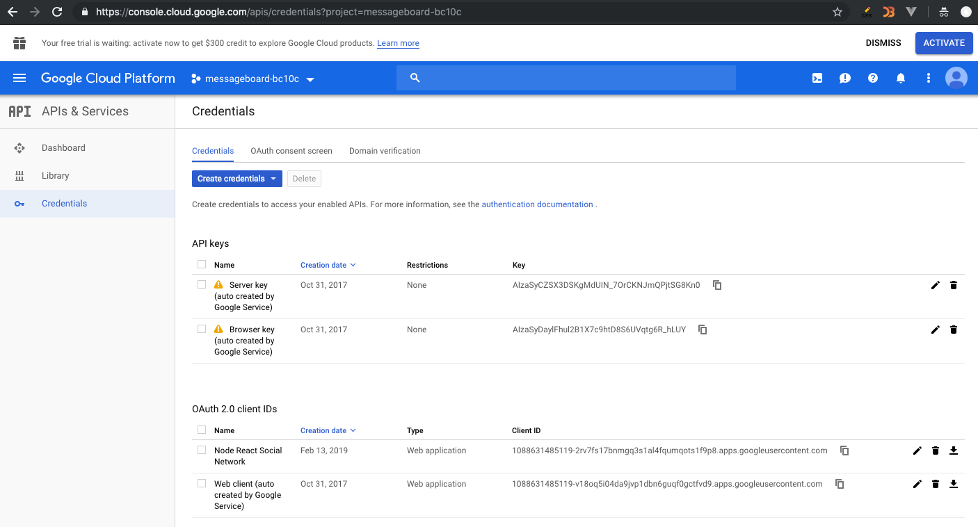

**/react-front/src/user/SocialLogin.js**

Let's see what response we get from google login by using console.log(). Then we will move on to complete implementation. **Make sure the change the clientId with your own google clientId.**

import React, { Component } from "react";

import GoogleLogin from "react-google-login";

class SocialLogin extends Component {

responseGoogle = response => {

console.log(response);

};

render() {

return (

<div className="container">

<GoogleLogin

clientId="269380407525-2cvoah9gpsjjffc5k1p6jkdjfd2vqfl4.apps.googleusercontent.com"

buttonText="Login with Google"

onSuccess={this.responseGoogle}

onFailure={this.responseGoogle}

/>

</div>

);

}

}

export default SocialLogin;

Before you try, make sure to import this component into Signin.js so that on signin page, user will get option to Login with Google.

**/react-front/src/user/Signin.js**

// import on top

import SocialLogin from "./SocialLogin";

// then inside render method

// right after the heading, put <SocialLogin /> component

<h2 className="mt-5 mb-5">Sign In</h2>

<hr />

<SocialLogin />

<hr />

**Now you see this beautiful Login with Google button on your Signin page.**

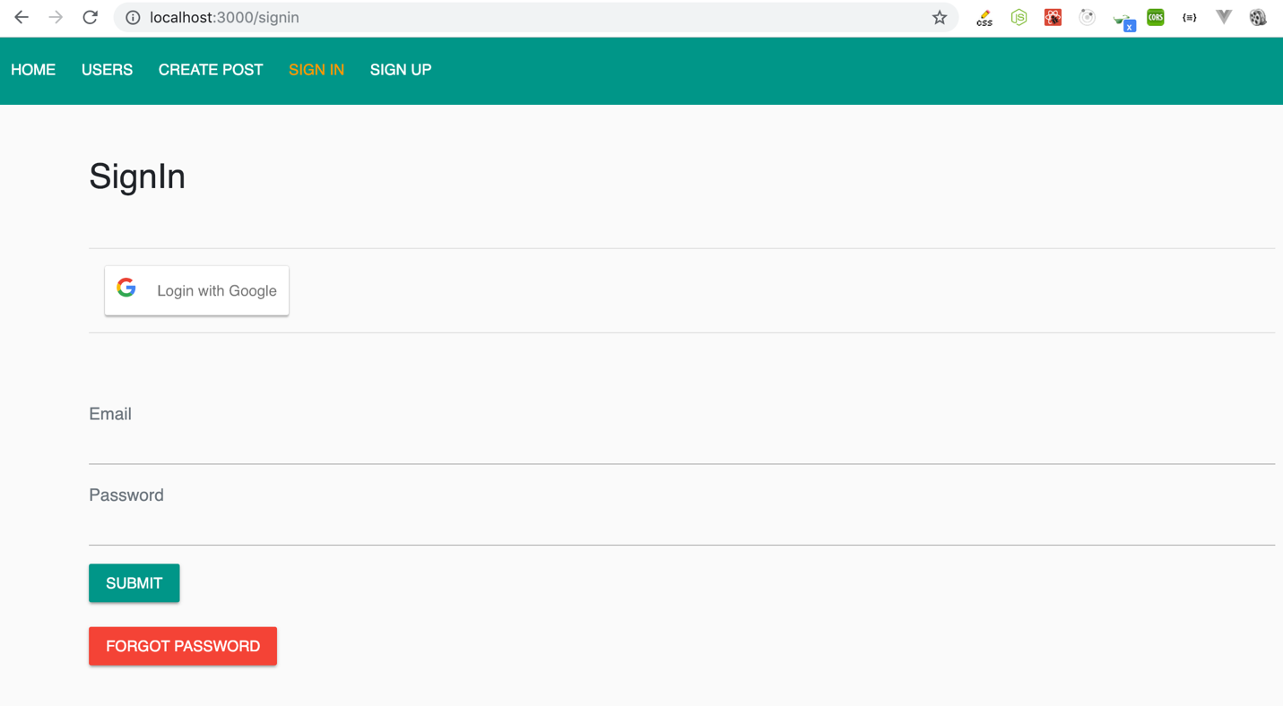

Click the Login with Google button and go ahead login to this app using your gmail account. Then open the console to see  what response you get from google. Here is the screenshot:

Google gives the user profile information as response. We are interested in profileObj.email and googleId

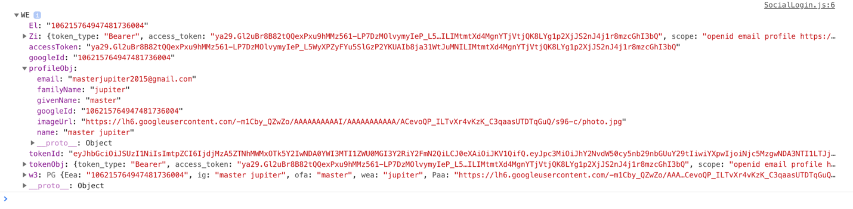

Ok, this was just to give you an idea of what happens when you login with social networks. The response will be similar if it was Login with Facebook etc

Now le'ts complete the rest of the work. First of all lets create socialLogin method in /auth/index.js

**/react-front/src/auth/index.js**

export const socialLogin = user => {

return fetch(`${process.env.REACT_APP_API_URL}/social-login/`, {

method: "POST",

headers: {

Accept: "application/json",

"Content-Type": "application/json"

},

// credentials: "include", // works only in the same origin

body: JSON.stringify(user)

})

.then(response => {

console.log("signin response: ", response);

return response.json();

})

.catch(err => console.log(err));

};

Now we can use this method to make a POST request to backend to log user using any Social Network. Lets import this in /user/SocialLogin.js and use. Here is the full code.

**/react-front/src/user/SocialLogin.js**

import React, { Component } from "react";

import { Redirect } from "react-router-dom";

import GoogleLogin from "react-google-login";

import { socialLogin, authenticate } from "../auth";

class SocialLogin extends Component {

constructor() {

super();

this.state = {

redirectToReferrer: false

};

}

responseGoogle = response => {

console.log(response);

const { googleId, name, email, imageUrl } = response.profileObj;

const user = {

password: googleId,

name: name,

email: email,

imageUrl: imageUrl

};

// console.log("user obj to social login: ", user);

socialLogin(user).then(data => {

console.log("signin data: ", data);

if (data.error) {

console.log("Error Login. Please try again..");

} else {

console.log("signin success - setting jwt: ", data);

authenticate(data, () => {

this.setState({ redirectToReferrer: true });

});

}

});

};

render() {

// redirect

const { redirectToReferrer } = this.state;

if (redirectToReferrer) {

return <Redirect to="/" />;

}

return (

<GoogleLogin

clientId="679380407525-2cvoah9gpsjjffc5k1p6atahhf2vqfl4.apps.googleusercontent.com"

buttonText="Login with Google"

onSuccess={this.responseGoogle}

onFailure={this.responseGoogle}

/>

);

}

}

export default SocialLogin;

And there you go!!! Now you can login with Google :)